34.83: a) From the diagram:
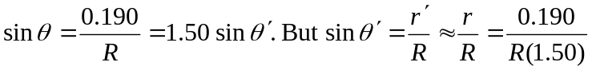
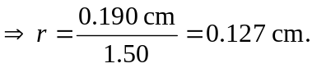
So the diameter of the light hitting the surface is 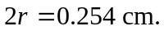
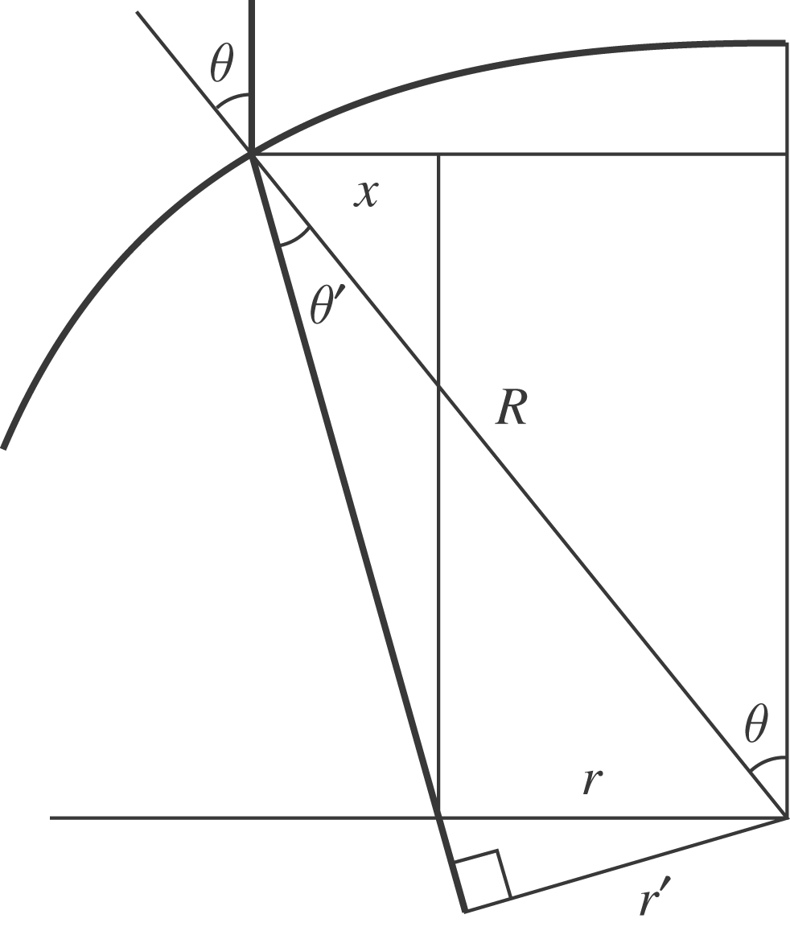

b) There is no dependence on the radius of the glass sphere in the calculation above.

